|  |  |  |  |  |  |
| --- | --- | --- | --- | --- | --- |
|  | **Déploiement Azure** | | |  | |
| **De :** | | **Date** | **29/11/2021** | | |
| **Date Etude** |  | | |
| **A :** | | | | | |
| **Cc :** | | | | | |
| **Objet** :  **Déploiement Azure** | | | | | **Importance :** Standard |

Déploiement Azure

Historique du document

|  |  |  |
| --- | --- | --- |
| Date de modification | Nom | Commentaire |
|  | Anis BEN ASKER | Création du document |

Table des matières

1 Présentation 3

2 Configuration MSAL 3

2.1 Application Azure Frontend : 4

2.2 Application Azure Backend : 6

2.3 Application Azure STS-relay 8

2.4 Application Azure STS-Relay-Ext 11

2.5 Portail Api External 11

2.6 Manifeste (Version DEV) 12

2.6.1 backends.webapi 12

2.6.2 Portail DomusVi (Developpement) 14

2.6.3 STS-relay 18

2.6.4 STS-Relay-Ext 21

2.6.5 Portail Api External 24

2.7 Points à revoir 28

# Présentation

Ce document a vocation d’identifier les actions à faire permettant :

* Déploiement MSAL sur Azure

# Configuration MSAL

URL : <https://portal.azure.com/>

Compte de dev : [serviceportail@domusvi.net](mailto:serviceportail@domusvi.net)

Azure Active Directory

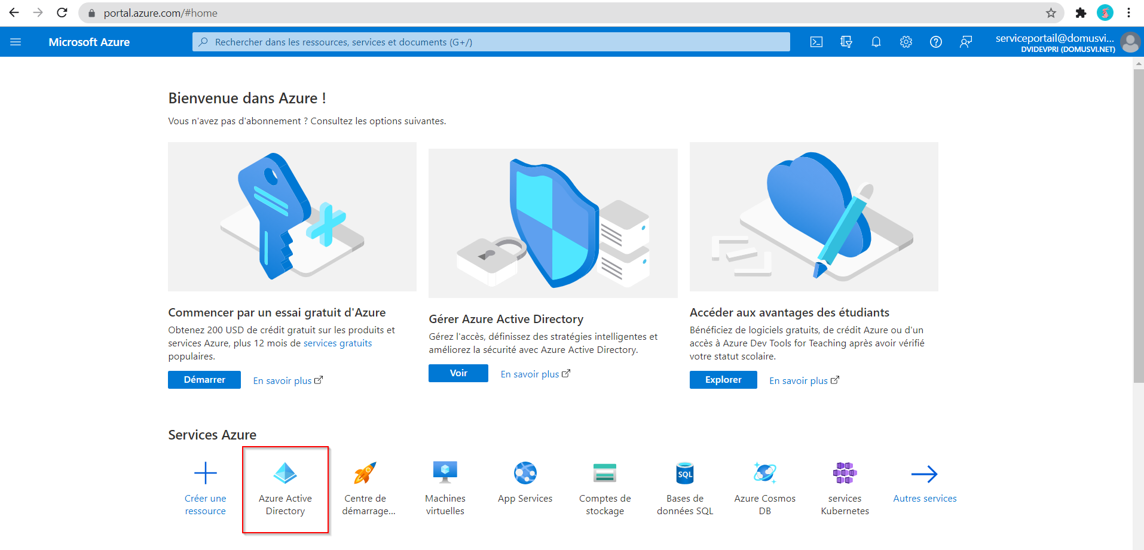

Applications d'entreprise | Toutes les applications

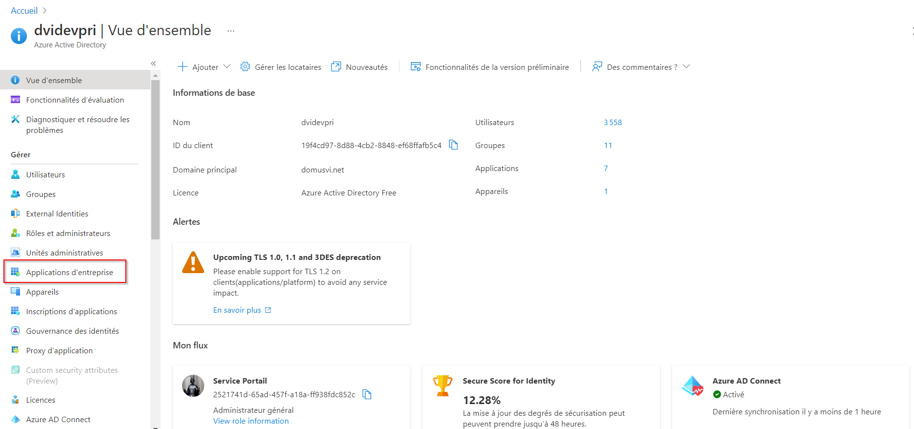

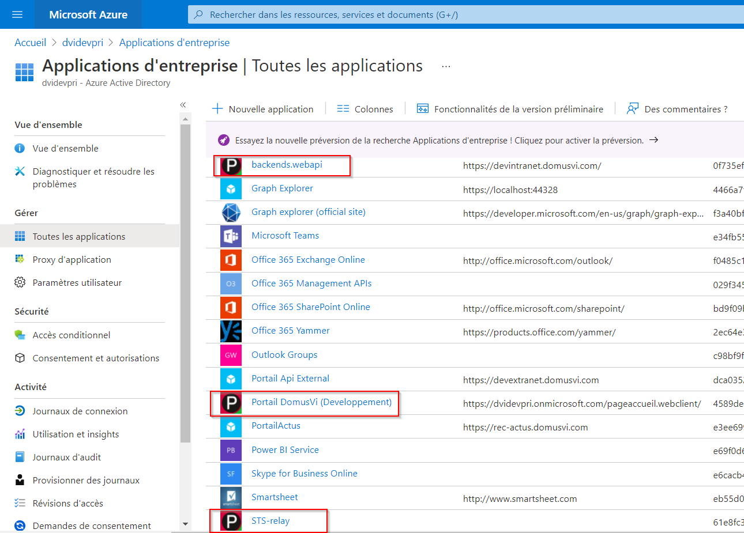

## Application Azure Frontend :

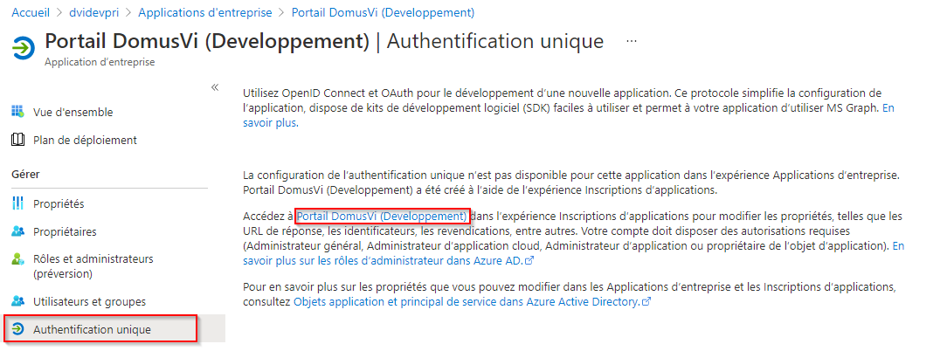

Certificats & secrets

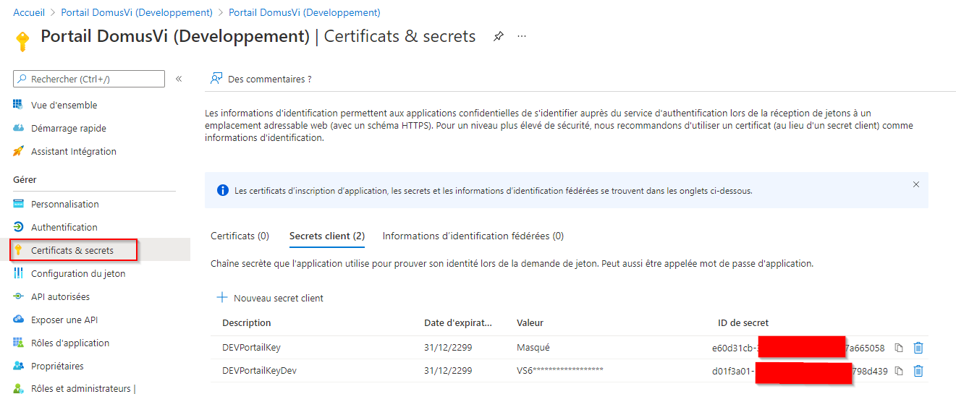

APIs autorisées

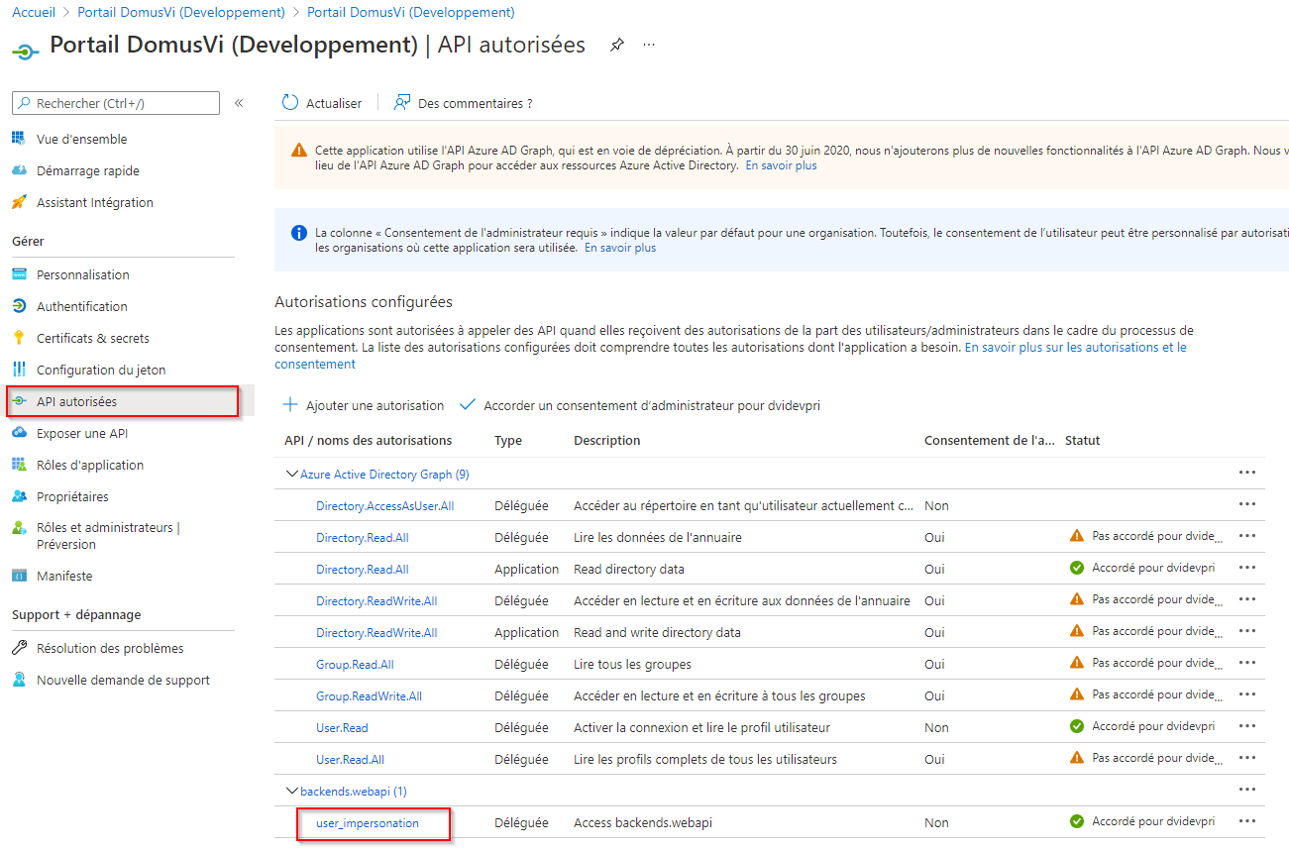

Il faut « Accorder un consentement d’administrateur pour XXX »

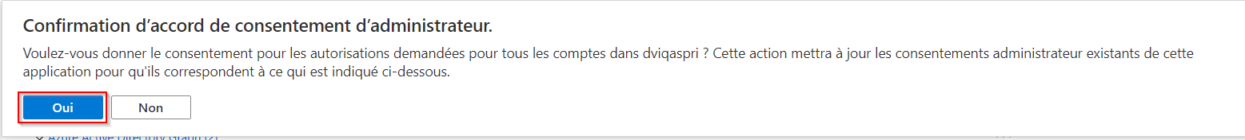

URLs de redirection Azure

Il faut les mettre en minuscule

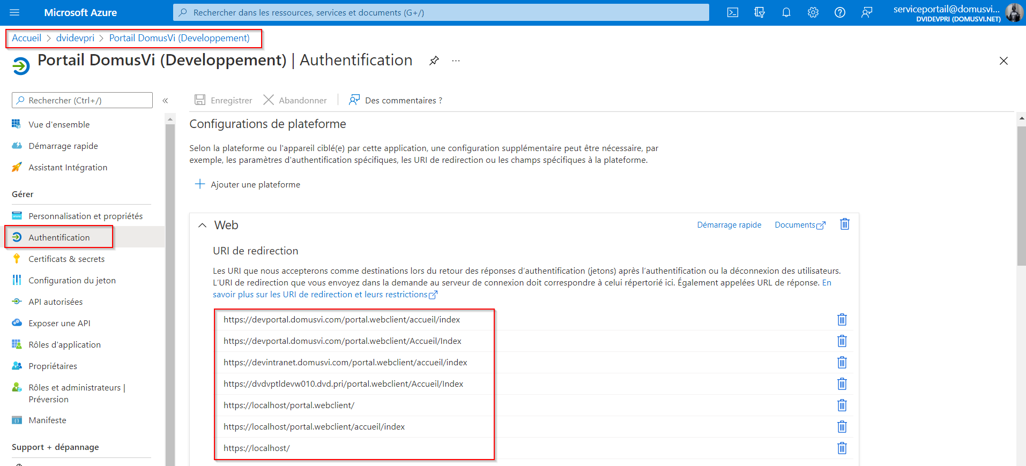

## Application Azure Backend :

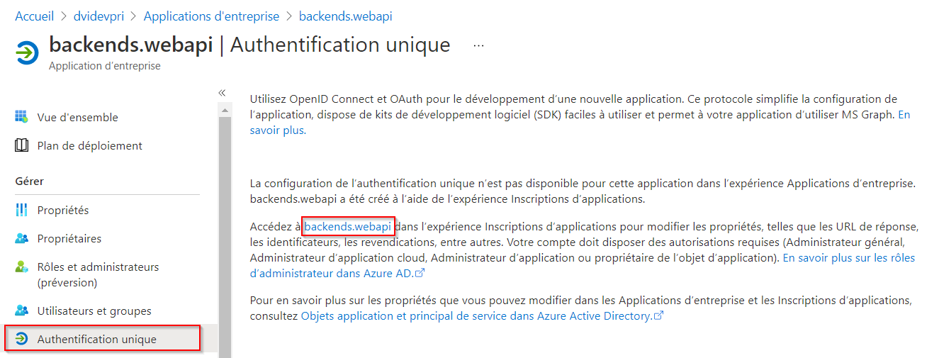

Certificats & secrets

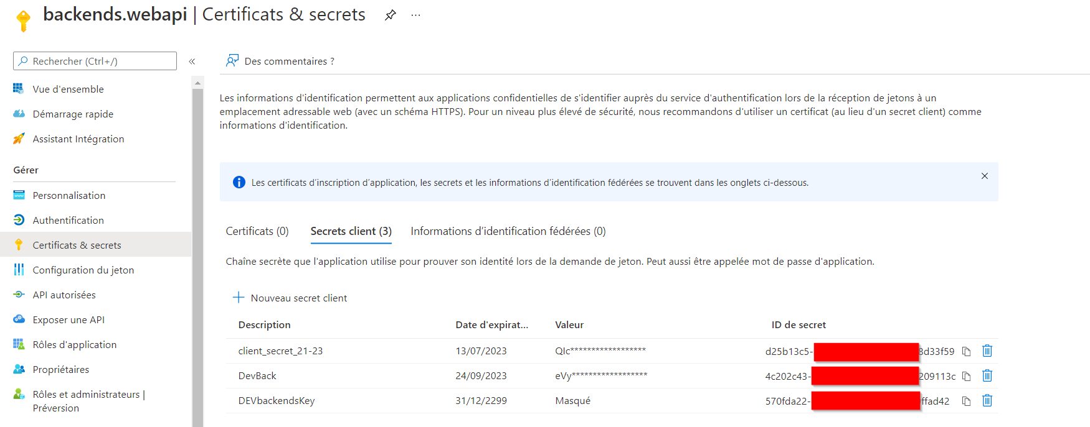

API autorisées

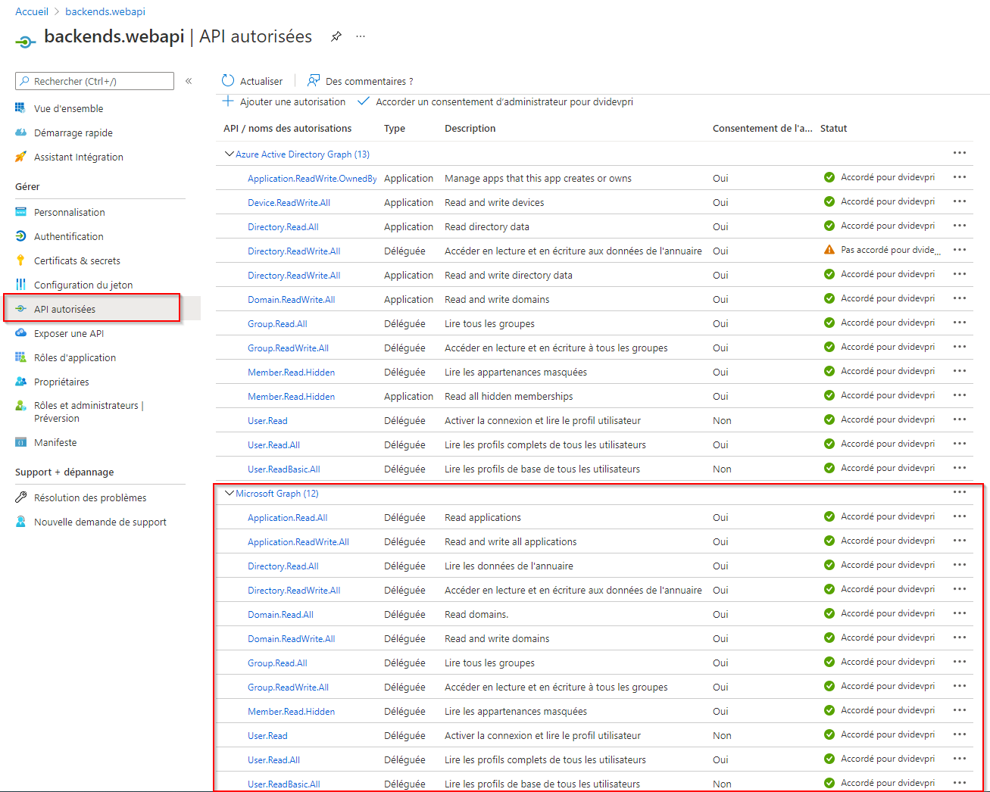

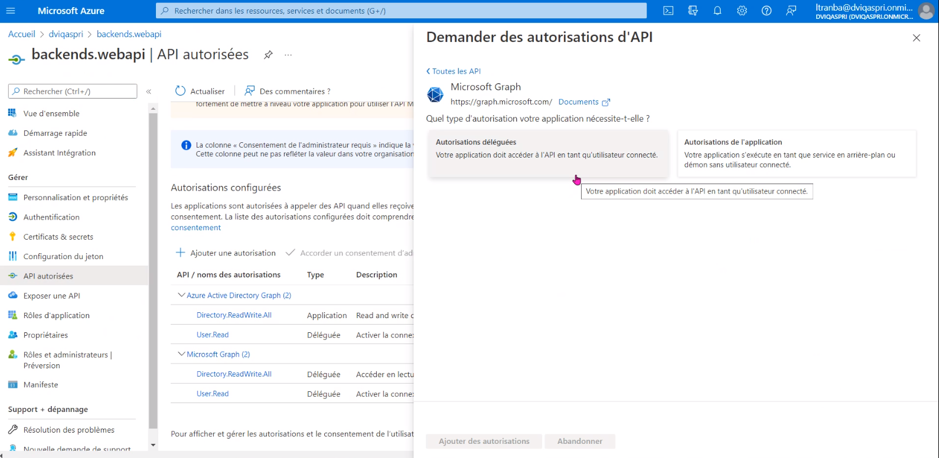

Il faut « Accorder un consentement d’administrateur pour XXX »



Sécurité : Autorisations

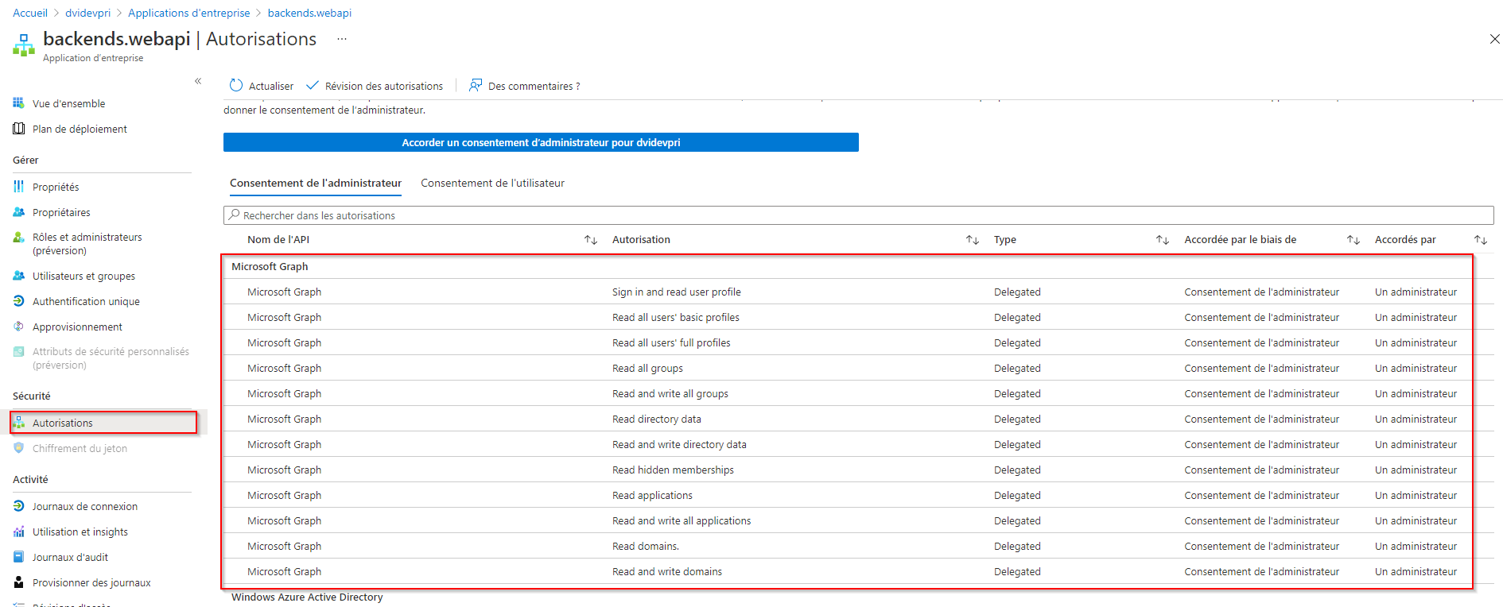

Authetification

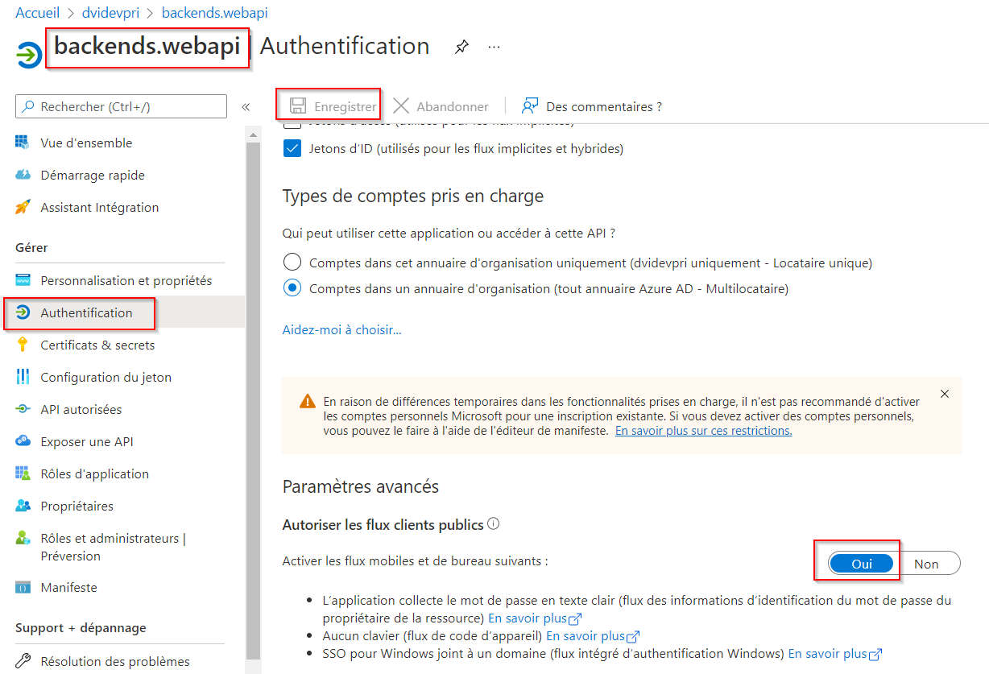

## Application Azure STS-relay

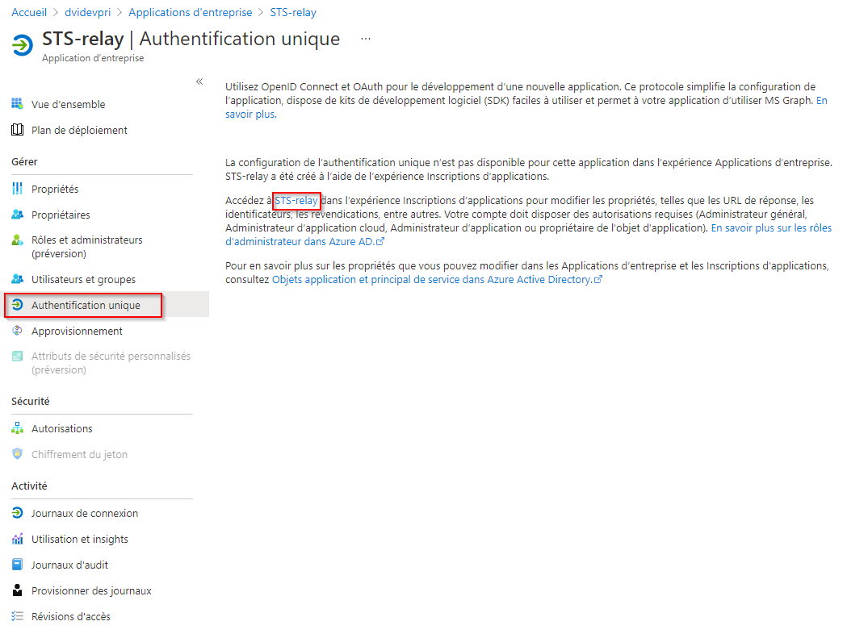

APIs autorisées

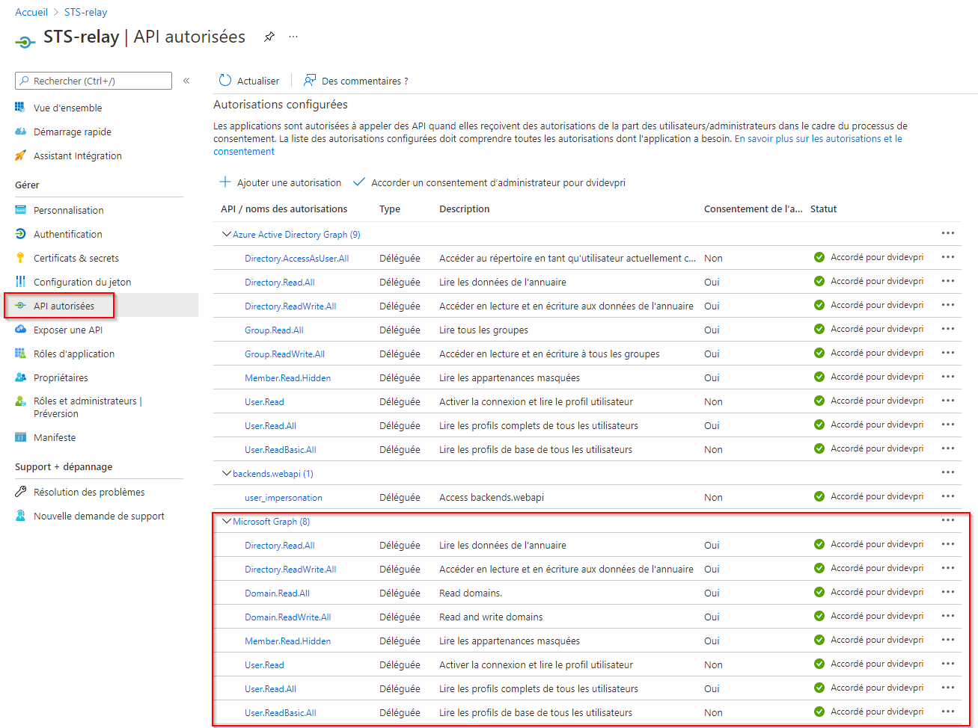

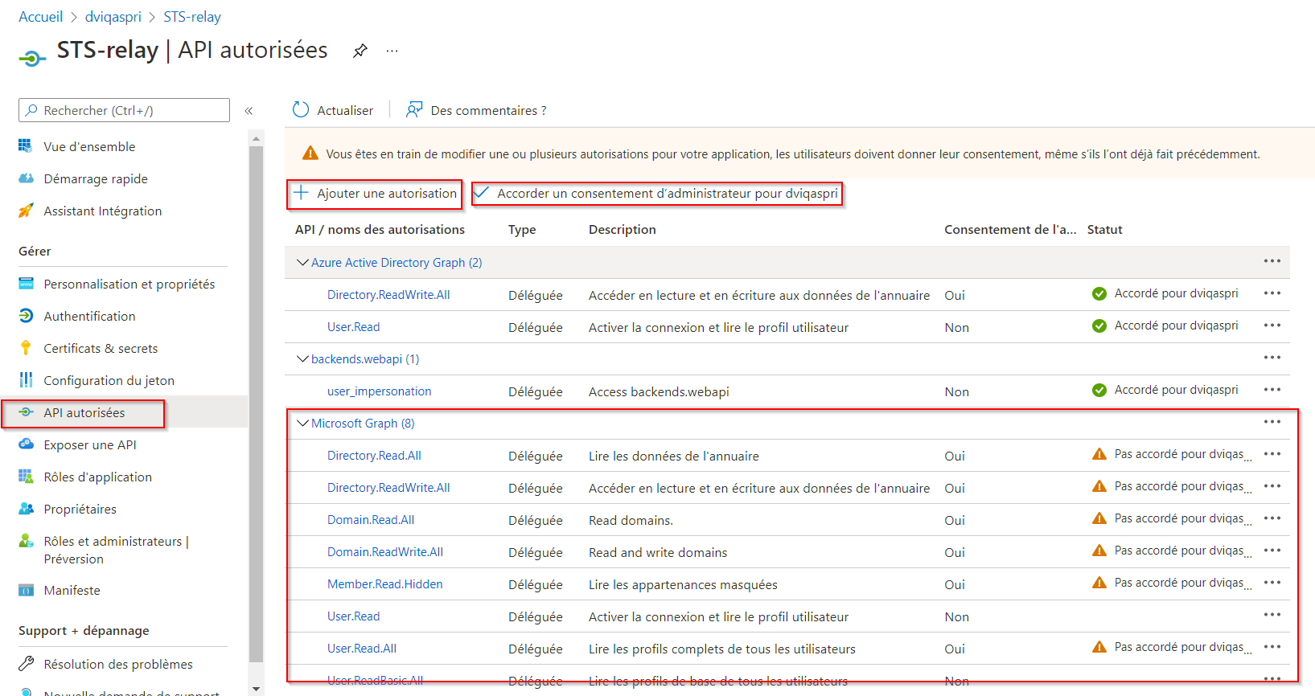

Il faut « Accorder un consentement d’administrateur pour XXX »



## Application Azure STS-Relay-Ext

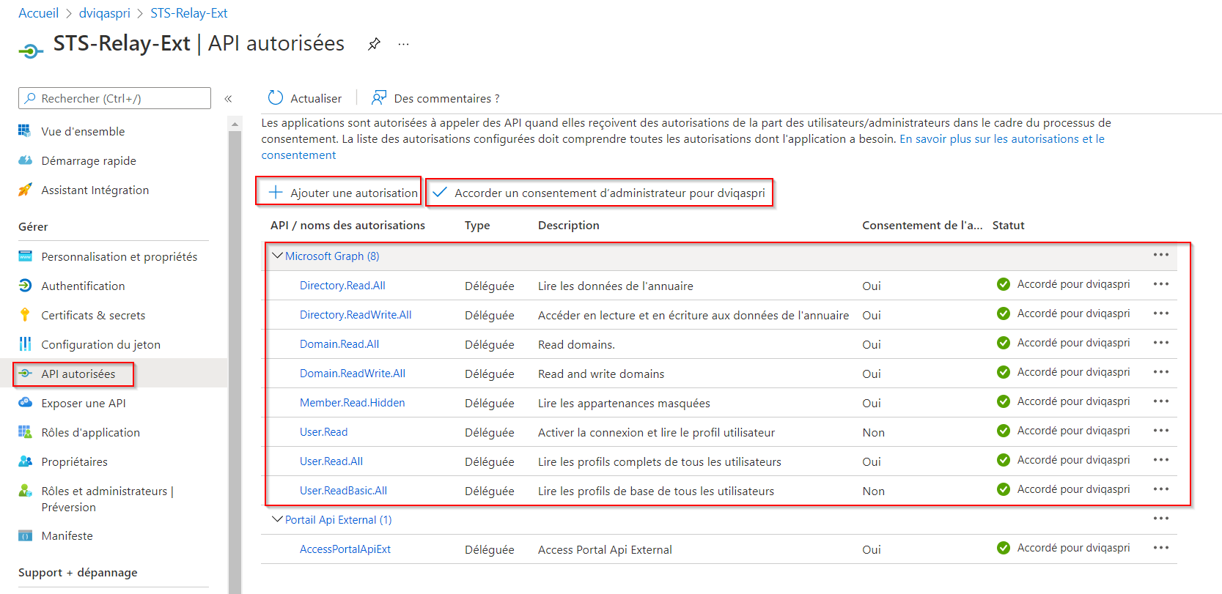

Attention :

PROD : AccessPortalApiExternal

Autre environnement : AccessPortalApiExt

## Portail Api External

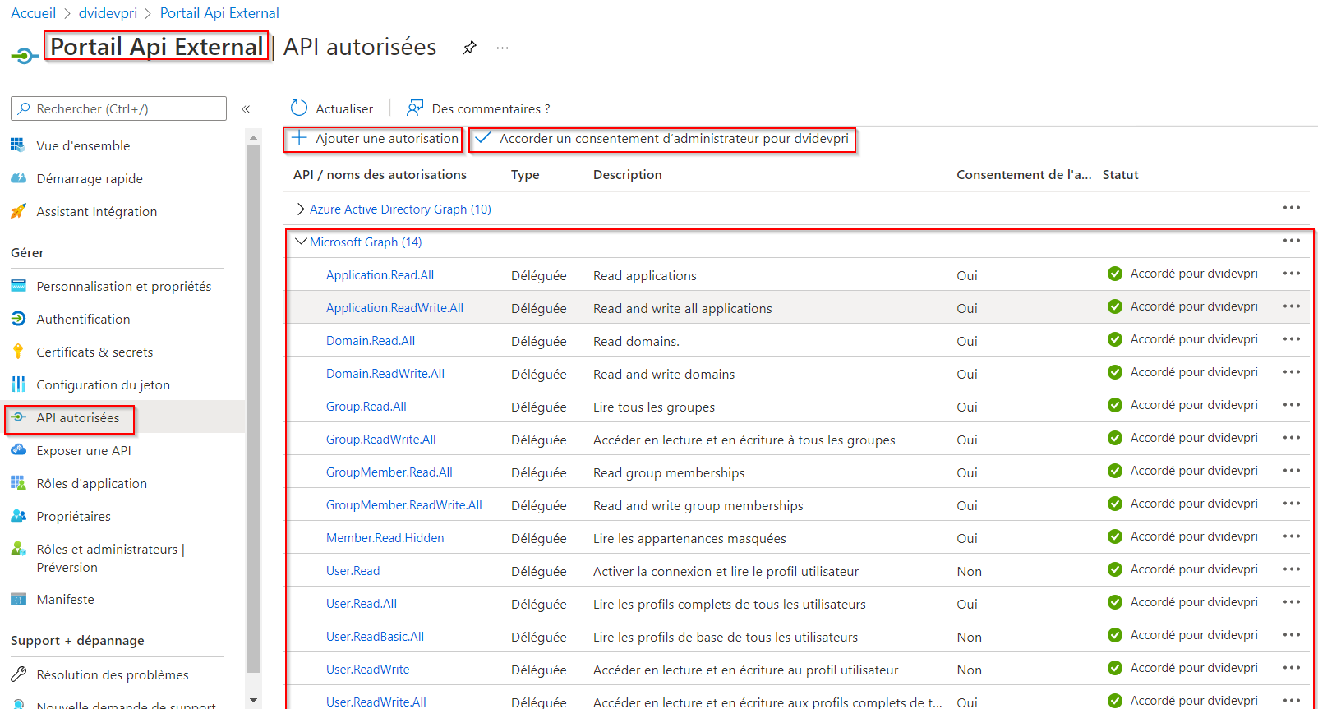

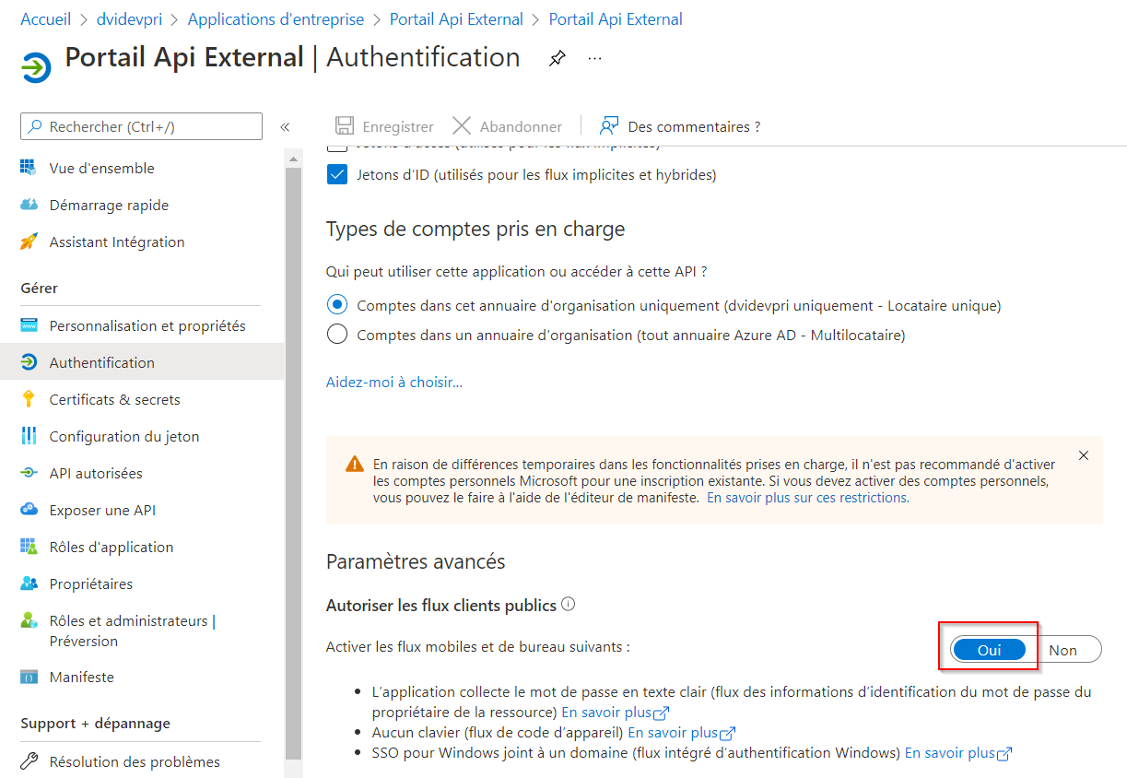

## Manifeste (Version DEV)

### backends.webapi

|  |
| --- |
| {      "id": "f4b508bd-7050-4d25-94e7-7a82107dca54",      "acceptMappedClaims": null,      "accessTokenAcceptedVersion": null,      "addIns": [],      "allowPublicClient": null,      "appId": "2cb782c1-9b68-45ad-a31c-8887cc4c3c1b",      "appRoles": [],      "oauth2AllowUrlPathMatching": false,      "createdDateTime": "2016-03-22T14:31:45Z",      "certification": null,      "disabledByMicrosoftStatus": null,      "groupMembershipClaims": null,      "identifierUris": [          "https://dvdpri.onmicrosoft.com/Backends.webapi"      ],      "informationalUrls": {          "termsOfService": null,          "support": null,          "privacy": null,          "marketing": null      },      "keyCredentials": [],      "knownClientApplications": [],      "logoUrl": null,      "logoutUrl": null,      "name": "backends.webapi",      "oauth2AllowIdTokenImplicitFlow": true,      "oauth2AllowImplicitFlow": false,      "oauth2Permissions": [          {              "adminConsentDescription": "Allow the application to access backends.webapi on behalf of the signed-in user.",              "adminConsentDisplayName": "Access backends.webapi",              "id": "6863f673-30b2-47ba-b8ca-64726de89890",              "isEnabled": true,              "lang": null,              "origin": "Application",              "type": "User",              "userConsentDescription": "Allow the application to access backends.webapi on your behalf.",              "userConsentDisplayName": "Access backends.webapi",              "value": "user_impersonation"          }      ],      "oauth2RequirePostResponse": false,      "optionalClaims": null,      "orgRestrictions": [],      "parentalControlSettings": {          "countriesBlockedForMinors": [],          "legalAgeGroupRule": "Allow"      },      "passwordCredentials": [          {              "customKeyIdentifier": null,              "endDate": "2018-03-22T14:41:44.9743004Z",              "keyId": "43e8b066-2d1e-4bd0-b78c-3b05ae726f93",              "startDate": "2016-03-22T14:41:44.9743004Z",              "value": null,              "createdOn": null,              "hint": null,              "displayName": null          },          {              "customKeyIdentifier": "UABSAEQAYgBhAGMAawBlAG4AZABLAGUAeQA=",              "endDate": "2299-12-30T23:00:00Z",              "keyId": "3e881e77-fdda-442d-aecb-f585b9a9da3b",              "startDate": "2018-03-16T09:08:03.1085056Z",              "value": null,              "createdOn": null,              "hint": null,              "displayName": null          }      ],      "preAuthorizedApplications": [],      "publisherDomain": null,      "replyUrlsWithType": [          {              "url": "https://portal.domusvi.com/",              "type": "Web"          }      ],      "requiredResourceAccess": [          {              "resourceAppId": "00000002-0000-0000-c000-000000000000",              "resourceAccess": [                  {                      "id": "78c8a3c8-a07e-4b9e-af1b-b5ccab50a175",                      "type": "Role"                  },                  {                      "id": "311a71cc-e848-46a1-bdf8-97ff7156d8e6",                      "type": "Scope"                  }              ]          }      ],      "samlMetadataUrl": null,      "signInUrl": "https://portal.domusvi.com",      "signInAudience": "AzureADMyOrg",      "tags": [],      "tokenEncryptionKeyId": null  } |

### Portail DomusVi (Developpement)

|  |
| --- |
| {      "id": "ed0b958a-4f20-43d2-8d48-a7130716247c",      "acceptMappedClaims": null,      "accessTokenAcceptedVersion": null,      "addIns": [],      "allowPublicClient": null,      "appId": "f9b27415-03f0-4091-8de4-4c4ef11f6871",      "appRoles": [],      "oauth2AllowUrlPathMatching": false,      "createdDateTime": "2016-03-03T15:17:41Z",      "certification": null,      "disabledByMicrosoftStatus": null,      "groupMembershipClaims": null,      "identifierUris": [          "https://dvidevpri.onmicrosoft.com/users.webclient/"      ],      "informationalUrls": {          "termsOfService": null,          "support": null,          "privacy": null,          "marketing": null      },      "keyCredentials": [],      "knownClientApplications": [],      "logoUrl": "https://secure.aadcdn.microsoftonline-p.com/c1c6b6c8-cxflx9lidlvacy5lu2ao4ezu2jrfz6frnw64bjlz2c0/appbranding/nw-tjsfis1q-ukojqtcuqsrkacn08zsrof3shakkzm/1033/bannerlogo?ts=637026327183953971",      "logoutUrl": null,      "name": "Portail DomusVi (Developpement)",      "oauth2AllowIdTokenImplicitFlow": true,      "oauth2AllowImplicitFlow": false,      "oauth2Permissions": [          {              "adminConsentDescription": "Allow the application to access frontends.webclient on behalf of the signed-in user.",              "adminConsentDisplayName": "Access frontends.webclient",              "id": "1bcd1fc5-a85d-4833-a7ee-4d1eabc5c390",              "isEnabled": true,              "lang": null,              "origin": "Application",              "type": "User",              "userConsentDescription": "Allow the application to access frontends.webclient on your behalf.",              "userConsentDisplayName": "Access frontends.webclient",              "value": "user_impersonation"          }      ],      "oauth2RequirePostResponse": false,      "optionalClaims": null,      "orgRestrictions": [],      "parentalControlSettings": {          "countriesBlockedForMinors": [],          "legalAgeGroupRule": "Allow"      },      "passwordCredentials": [          {              "customKeyIdentifier": "RABFAFYAUABvAHIAdABhAGkAbABLAGUAeQA=",              "endDate": "2299-12-30T23:00:00Z",              "keyId": "e60d31cb-34f4-4e00-a2d2-a68f7a665058",              "startDate": "2018-03-13T11:50:49.6923225Z",              "value": null,              "createdOn": null,              "hint": null,              "displayName": null          },          {              "customKeyIdentifier": null,              "endDate": "2299-12-30T23:00:00Z",              "keyId": "d01f3a01-17a1-4eb4-be14-a537a798d439",              "startDate": "2019-08-28T18:04:14.28Z",              "value": null,              "createdOn": "2019-08-28T18:04:14.4092088Z",              "hint": "VS6",              "displayName": "DEVPortailKeyDev"          }      ],      "preAuthorizedApplications": [],      "publisherDomain": null,      "replyUrlsWithType": [          {              "url": "https://localhost/portal.webclient/",              "type": "Web"          },          {              "url": "https://devportal.domusvi.com/portal.webclient/Accueil/Index/",              "type": "Web"          },          {              "url": "https://dvdvptldevw010.dvd.pri/portal.webclient/Accueil/Index/",              "type": "Web"          },          {              "url": "https://localhost/portal.webclient/accueil/index",              "type": "Web"          },          {              "url": "https://devintranet.domusvi.com/portal.webclient/accueil/index",              "type": "Web"          },          {              "url": "https://localhost/",              "type": "Web"          }      ],      "requiredResourceAccess": [          {              "resourceAppId": "00000002-0000-0000-c000-000000000000",              "resourceAccess": [                  {                      "id": "311a71cc-e848-46a1-bdf8-97ff7156d8e6",                      "type": "Scope"                  },                  {                      "id": "c582532d-9d9e-43bd-a97c-2667a28ce295",                      "type": "Scope"                  },                  {                      "id": "6234d376-f627-4f0f-90e0-dff25c5211a3",                      "type": "Scope"                  },                  {                      "id": "970d6fa6-214a-4a9b-8513-08fad511e2fd",                      "type": "Scope"                  },                  {                      "id": "78c8a3c8-a07e-4b9e-af1b-b5ccab50a175",                      "type": "Scope"                  },                  {                      "id": "5778995a-e1bf-45b8-affa-663a9f3f4d04",                      "type": "Scope"                  },                  {                      "id": "a42657d6-7f20-40e3-b6f0-cee03008a62a",                      "type": "Scope"                  },                  {                      "id": "78c8a3c8-a07e-4b9e-af1b-b5ccab50a175",                      "type": "Role"                  },                  {                      "id": "5778995a-e1bf-45b8-affa-663a9f3f4d04",                      "type": "Role"                  }              ]          },          {              "resourceAppId": "8a6cc09b-4cf3-4b73-90f9-5557014e1ab0",              "resourceAccess": [                  {                      "id": "fe262217-934d-4c7f-ba89-764b5e1aed28",                      "type": "Scope"                  }              ]          }      ],      "samlMetadataUrl": null,      "signInUrl": "https://dvidevpri.onmicrosoft.com/pageaccueil.webclient/",      "signInAudience": "AzureADMyOrg",      "tags": [],      "tokenEncryptionKeyId": null  } |

### STS-relay

|  |
| --- |
| {      "id": "f842acc7-698a-4cc8-ab0b-f0f57f0e5b83",      "acceptMappedClaims": null,      "accessTokenAcceptedVersion": null,      "addIns": [],      "allowPublicClient": true,      "appId": "fcd79044-d183-40ac-b5d5-31a38a2f64df",      "appRoles": [],      "oauth2AllowUrlPathMatching": false,      "createdDateTime": "2016-03-03T17:06:46Z",      "certification": null,      "disabledByMicrosoftStatus": null,      "groupMembershipClaims": "SecurityGroup",      "identifierUris": [],      "informationalUrls": {          "termsOfService": null,          "support": null,          "privacy": null,          "marketing": null      },      "keyCredentials": [],      "knownClientApplications": [],      "logoUrl": "https://secure.aadcdn.microsoftonline-p.com/c1c6b6c8-cxflx9lidlvacy5lu2ao4ezu2jrfz6frnw64bjlz2c0/appbranding/2ecav4iez5pyrmwhdab6fo-u7vfapuhl30-fawiu5e4/1033/bannerlogo?ts=637026696714241110",      "logoutUrl": null,      "name": "STS-relay",      "oauth2AllowIdTokenImplicitFlow": true,      "oauth2AllowImplicitFlow": false,      "oauth2Permissions": [],      "oauth2RequirePostResponse": false,      "optionalClaims": null,      "orgRestrictions": [],      "parentalControlSettings": {          "countriesBlockedForMinors": [],          "legalAgeGroupRule": "Allow"      },      "passwordCredentials": [],      "preAuthorizedApplications": [],      "publisherDomain": null,      "replyUrlsWithType": [          {              "url": "https://devintranet.domusvi.com/",              "type": "InstalledClient"          }      ],      "requiredResourceAccess": [          {              "resourceAppId": "00000003-0000-0000-c000-000000000000",              "resourceAccess": [                  {                      "id": "e1fe6dd8-ba31-4d61-89e7-88639da4683d",                      "type": "Scope"                  },                  {                      "id": "b340eb25-3456-403f-be2f-af7a0d370277",                      "type": "Scope"                  },                  {                      "id": "a154be20-db9c-4678-8ab7-66f6cc099a59",                      "type": "Scope"                  },                  {                      "id": "06da0dbc-49e2-44d2-8312-53f166ab848a",                      "type": "Scope"                  },                  {                      "id": "c5366453-9fb0-48a5-a156-24f0c49a4b84",                      "type": "Scope"                  },                  {                      "id": "f6a3db3e-f7e8-4ed2-a414-557c8c9830be",                      "type": "Scope"                  },                  {                      "id": "2f9ee017-59c1-4f1d-9472-bd5529a7b311",                      "type": "Scope"                  },                  {                      "id": "0b5d694c-a244-4bde-86e6-eb5cd07730fe",                      "type": "Scope"                  }              ]          },          {              "resourceAppId": "00000002-0000-0000-c000-000000000000",              "resourceAccess": [                  {                      "id": "2d05a661-f651-4d57-a595-489c91eda336",                      "type": "Scope"                  },                  {                      "id": "311a71cc-e848-46a1-bdf8-97ff7156d8e6",                      "type": "Scope"                  },                  {                      "id": "cba73afc-7f69-4d86-8450-4978e04ecd1a",                      "type": "Scope"                  },                  {                      "id": "c582532d-9d9e-43bd-a97c-2667a28ce295",                      "type": "Scope"                  },                  {                      "id": "6234d376-f627-4f0f-90e0-dff25c5211a3",                      "type": "Scope"                  },                  {                      "id": "970d6fa6-214a-4a9b-8513-08fad511e2fd",                      "type": "Scope"                  },                  {                      "id": "78c8a3c8-a07e-4b9e-af1b-b5ccab50a175",                      "type": "Scope"                  },                  {                      "id": "5778995a-e1bf-45b8-affa-663a9f3f4d04",                      "type": "Scope"                  },                  {                      "id": "a42657d6-7f20-40e3-b6f0-cee03008a62a",                      "type": "Scope"                  }              ]          },          {              "resourceAppId": "8a6cc09b-4cf3-4b73-90f9-5557014e1ab0",              "resourceAccess": [                  {                      "id": "fe262217-934d-4c7f-ba89-764b5e1aed28",                      "type": "Scope"                  }              ]          }      ],      "samlMetadataUrl": null,      "signInUrl": null,      "signInAudience": "AzureADMultipleOrgs",      "tags": [],      "tokenEncryptionKeyId": null  } |

### STS-Relay-Ext

|  |
| --- |
| {      "id": "674ae30e-6067-41f5-a1fc-7a3550e9b566",      "acceptMappedClaims": null,      "accessTokenAcceptedVersion": null,      "addIns": [],      "allowPublicClient": true,      "appId": "e745d6b3-c6ed-4237-99c0-12137dddec14",      "appRoles": [],      "oauth2AllowUrlPathMatching": false,      "createdDateTime": "2021-02-17T15:49:07Z",      "description": null,      "certification": null,      "disabledByMicrosoftStatus": null,      "groupMembershipClaims": null,      "identifierUris": [],      "informationalUrls": {          "termsOfService": null,          "support": null,          "privacy": null,          "marketing": null      },      "keyCredentials": [],      "knownClientApplications": [],      "logoUrl": null,      "logoutUrl": "https://devextranet.domusvi.com/logout",      "name": "STS-Relay-Ext",      "notes": null,      "oauth2AllowIdTokenImplicitFlow": true,      "oauth2AllowImplicitFlow": true,      "oauth2Permissions": [],      "oauth2RequirePostResponse": false,      "optionalClaims": null,      "orgRestrictions": [],      "parentalControlSettings": {          "countriesBlockedForMinors": [],          "legalAgeGroupRule": "Allow"      },      "passwordCredentials": [          {              "customKeyIdentifier": null,              "endDate": "2299-12-30T23:00:00Z",              "keyId": "ae753d68-9207-4bbf-891c-d549e95d2ac6",              "startDate": "2021-03-04T13:41:25.738Z",              "value": null,              "createdOn": "2021-03-04T13:41:25.9769649Z",              "hint": "_._",              "displayName": "Clé Secrete"          }      ],      "preAuthorizedApplications": [],      "publisherDomain": "domusvi.net",      "replyUrlsWithType": [          {              "url": "https://localhost/",              "type": "InstalledClient"          },          {              "url": "https://localhost",              "type": "Web"          },          {              "url": "msale745d6b3-c6ed-4237-99c0-12137dddec14://auth",              "type": "InstalledClient"          },          {              "url": "https://login.live.com/oauth20_desktop.srf",              "type": "InstalledClient"          },          {              "url": "https://login.microsoftonline.com/common/oauth2/nativeclient",              "type": "InstalledClient"          },          {              "url": "https://devextranet.domusvi.com",              "type": "Web"          },          {              "url": "https://devextranet.domusvi.com/",              "type": "InstalledClient"          }      ],      "requiredResourceAccess": [          {              "resourceAppId": "00000003-0000-0000-c000-000000000000",              "resourceAccess": [                  {                      "id": "e1fe6dd8-ba31-4d61-89e7-88639da4683d",                      "type": "Scope"                  },                  {                      "id": "b340eb25-3456-403f-be2f-af7a0d370277",                      "type": "Scope"                  },                  {                      "id": "a154be20-db9c-4678-8ab7-66f6cc099a59",                      "type": "Scope"                  },                  {                      "id": "06da0dbc-49e2-44d2-8312-53f166ab848a",                      "type": "Scope"                  },                  {                      "id": "c5366453-9fb0-48a5-a156-24f0c49a4b84",                      "type": "Scope"                  },                  {                      "id": "f6a3db3e-f7e8-4ed2-a414-557c8c9830be",                      "type": "Scope"                  },                  {                      "id": "2f9ee017-59c1-4f1d-9472-bd5529a7b311",                      "type": "Scope"                  },                  {                      "id": "0b5d694c-a244-4bde-86e6-eb5cd07730fe",                      "type": "Scope"                  }              ]          },          {              "resourceAppId": "be340a62-3eec-4d28-ace6-290413b9c495",              "resourceAccess": [                  {                      "id": "b1ba88ff-f70c-485a-9d55-af88ed63191c",                      "type": "Scope"                  }              ]          }      ],      "samlMetadataUrl": null,      "serviceManagementReference": null,      "signInUrl": null,      "signInAudience": "AzureADMultipleOrgs",      "tags": [],      "tokenEncryptionKeyId": null  } |

### Portail Api External

|  |
| --- |
| {      "id": "92829363-bb5d-4cf3-9c50-2c42459a26c2",      "acceptMappedClaims": null,      "accessTokenAcceptedVersion": null,      "addIns": [],      "allowPublicClient": true,      "appId": "be340a62-3eec-4d28-ace6-290413b9c495",      "appRoles": [          {              "allowedMemberTypes": [                  "User"              ],              "description": "permet de poster ou consulter des propositions d'orientations ",              "displayName": "placement_agency",              "id": "adc5eefb-e83c-44d6-b07d-7fd464c41fd2",              "isEnabled": true,              "lang": null,              "origin": "Application",              "value": "prospects.Write"          }      ],      "oauth2AllowUrlPathMatching": false,      "createdDateTime": "2021-02-17T13:23:32Z",      "description": null,      "certification": null,      "disabledByMicrosoftStatus": null,      "groupMembershipClaims": null,      "identifierUris": [          "api://be340a62-3eec-4d28-ace6-290413b9c495"      ],      "informationalUrls": {          "termsOfService": null,          "support": null,          "privacy": null,          "marketing": null      },      "keyCredentials": [],      "knownClientApplications": [],      "logoUrl": null,      "logoutUrl": null,      "name": "Portail Api External",      "notes": null,      "oauth2AllowIdTokenImplicitFlow": true,      "oauth2AllowImplicitFlow": false,      "oauth2Permissions": [          {              "adminConsentDescription": "Access Portal Api External",              "adminConsentDisplayName": "Access Portal Api External",              "id": "b1ba88ff-f70c-485a-9d55-af88ed63191c",              "isEnabled": true,              "lang": null,              "origin": "Application",              "type": "Admin",              "userConsentDescription": null,              "userConsentDisplayName": null,              "value": "AccessPortalApiExt"          }      ],      "oauth2RequirePostResponse": false,      "optionalClaims": null,      "orgRestrictions": [],      "parentalControlSettings": {          "countriesBlockedForMinors": [],          "legalAgeGroupRule": "Allow"      },      "passwordCredentials": [          {              "customKeyIdentifier": null,              "endDate": "2299-12-30T23:00:00Z",              "keyId": "1bf3e789-57e7-41eb-b7f9-1f034e3453cb",              "startDate": "2021-03-17T14:31:41.002Z",              "value": null,              "createdOn": "2021-03-17T14:31:41.3173997Z",              "hint": "Q_r",              "displayName": "Password uploaded on Wed Mar 17 2021"          },          {              "customKeyIdentifier": null,              "endDate": "2299-12-30T23:00:00Z",              "keyId": "c5644530-83a3-4e79-8e79-b6777d144b4f",              "startDate": "2021-03-10T22:00:25.509Z",              "value": null,              "createdOn": "2021-03-10T22:00:26.0258778Z",              "hint": "1.5",              "displayName": "Client secret"          }      ],      "preAuthorizedApplications": [],      "publisherDomain": "domusvi.net",      "replyUrlsWithType": [          {              "url": "https://localhost",              "type": "InstalledClient"          },          {              "url": "https://devextranet.domusvi.com/",              "type": "Web"          },          {              "url": "https://localhost/",              "type": "Web"          }      ],      "requiredResourceAccess": [          {              "resourceAppId": "00000003-0000-0000-c000-000000000000",              "resourceAccess": [                  {                      "id": "e1fe6dd8-ba31-4d61-89e7-88639da4683d",                      "type": "Scope"                  },                  {                      "id": "b4e74841-8e56-480b-be8b-910348b18b4c",                      "type": "Scope"                  },                  {                      "id": "b340eb25-3456-403f-be2f-af7a0d370277",                      "type": "Scope"                  },                  {                      "id": "a154be20-db9c-4678-8ab7-66f6cc099a59",                      "type": "Scope"                  },                  {                      "id": "204e0828-b5ca-4ad8-b9f3-f32a958e7cc4",                      "type": "Scope"                  },                  {                      "id": "5f8c59db-677d-491f-a6b8-5f174b11ec1d",                      "type": "Scope"                  },                  {                      "id": "4e46008b-f24c-477d-8fff-7bb4ec7aafe0",                      "type": "Scope"                  },                  {                      "id": "f6a3db3e-f7e8-4ed2-a414-557c8c9830be",                      "type": "Scope"                  },                  {                      "id": "c79f8feb-a9db-4090-85f9-90d820caa0eb",                      "type": "Scope"                  },                  {                      "id": "bdfbf15f-ee85-4955-8675-146e8e5296b5",                      "type": "Scope"                  },                  {                      "id": "bc024368-1153-4739-b217-4326f2e966d0",                      "type": "Scope"                  },                  {                      "id": "f81125ac-d3b7-4573-a3b2-7099cc39df9e",                      "type": "Scope"                  },                  {                      "id": "2f9ee017-59c1-4f1d-9472-bd5529a7b311",                      "type": "Scope"                  },                  {                      "id": "0b5d694c-a244-4bde-86e6-eb5cd07730fe",                      "type": "Scope"                  }              ]          },          {              "resourceAppId": "00000002-0000-0000-c000-000000000000",              "resourceAccess": [                  {                      "id": "2d05a661-f651-4d57-a595-489c91eda336",                      "type": "Scope"                  },                  {                      "id": "311a71cc-e848-46a1-bdf8-97ff7156d8e6",                      "type": "Scope"                  },                  {                      "id": "cba73afc-7f69-4d86-8450-4978e04ecd1a",                      "type": "Scope"                  },                  {                      "id": "c582532d-9d9e-43bd-a97c-2667a28ce295",                      "type": "Scope"                  },                  {                      "id": "6234d376-f627-4f0f-90e0-dff25c5211a3",                      "type": "Scope"                  },                  {                      "id": "970d6fa6-214a-4a9b-8513-08fad511e2fd",                      "type": "Scope"                  },                  {                      "id": "78c8a3c8-a07e-4b9e-af1b-b5ccab50a175",                      "type": "Scope"                  },                  {                      "id": "5778995a-e1bf-45b8-affa-663a9f3f4d04",                      "type": "Scope"                  },                  {                      "id": "a42657d6-7f20-40e3-b6f0-cee03008a62a",                      "type": "Scope"                  },                  {                      "id": "80e5b1bf-3ad0-4365-943a-0ec983009b67",                      "type": "Scope"                  }              ]          }      ],      "samlMetadataUrl": null,      "serviceManagementReference": null,      "signInUrl": "https://devextranet.domusvi.com",      "signInAudience": "AzureADMyOrg",      "tags": [],      "tokenEncryptionKeyId": null  } |

## Points à revoir

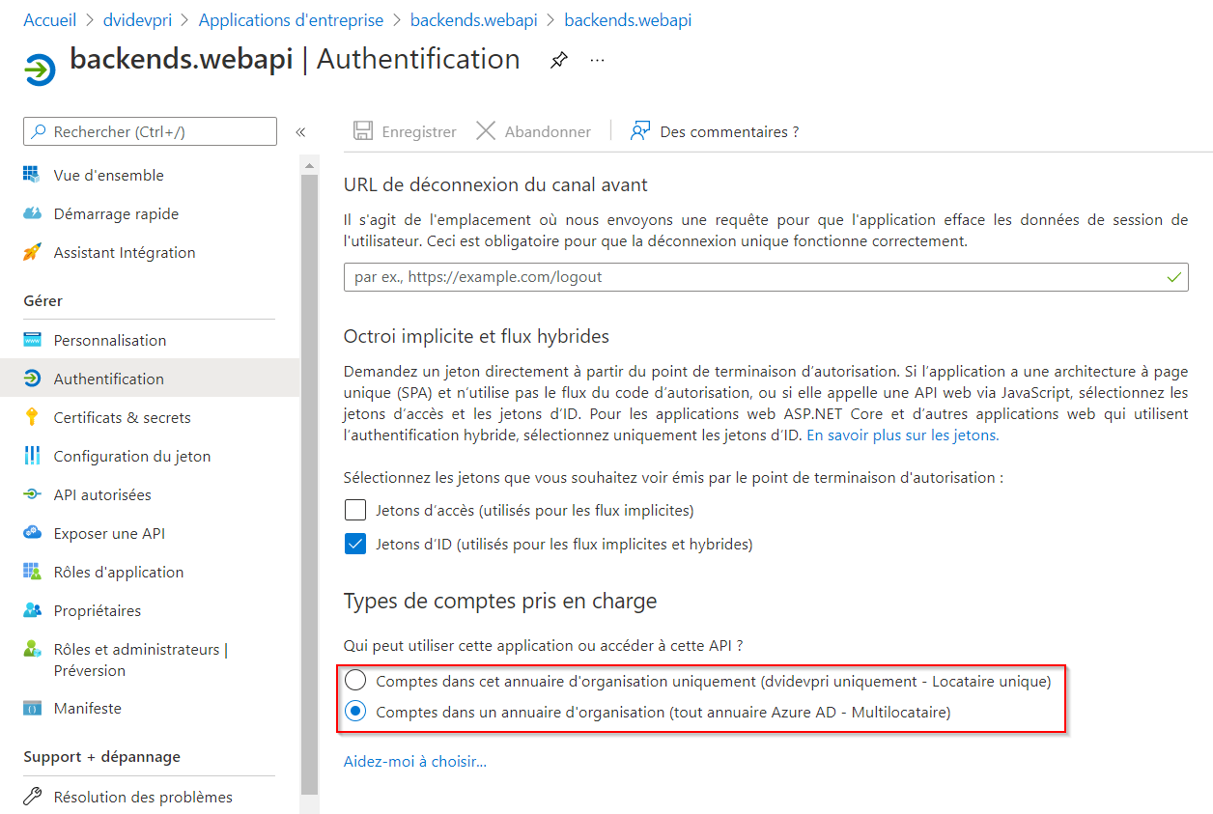

C’est pas la même configuration en prod !!

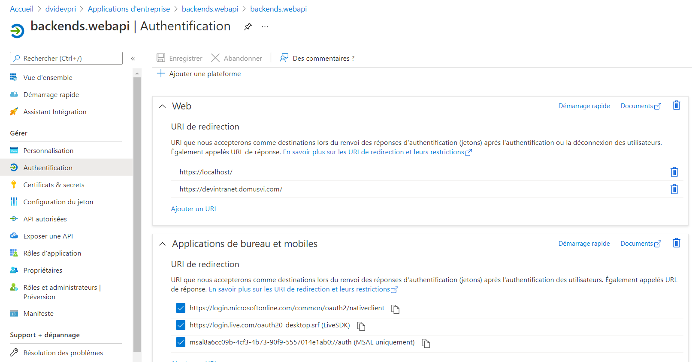

La partie Applications de bureau et mobiles n’existe pas en Prod et en QAS.

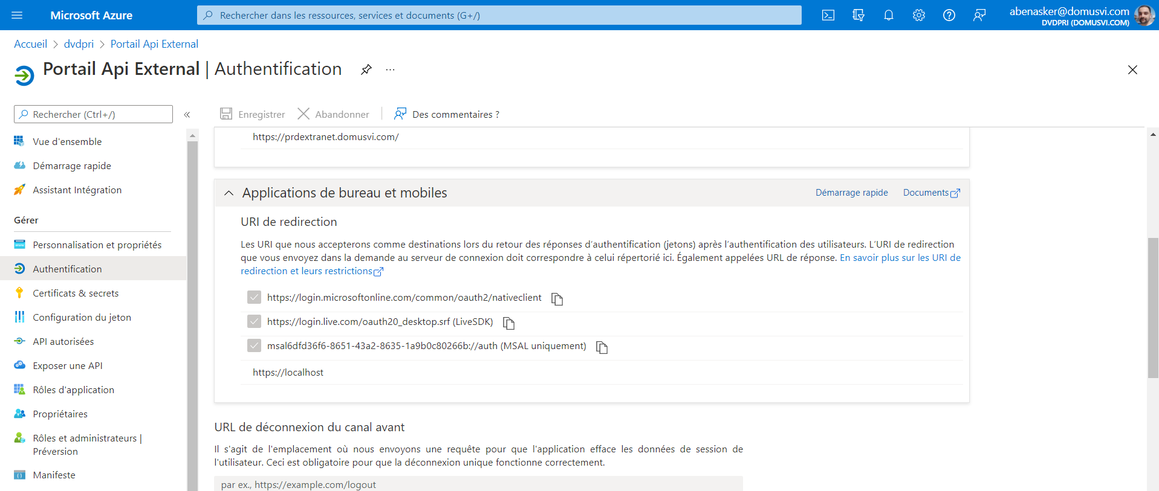

Les 3 cases à cocher sont cochées qu’en PROD !

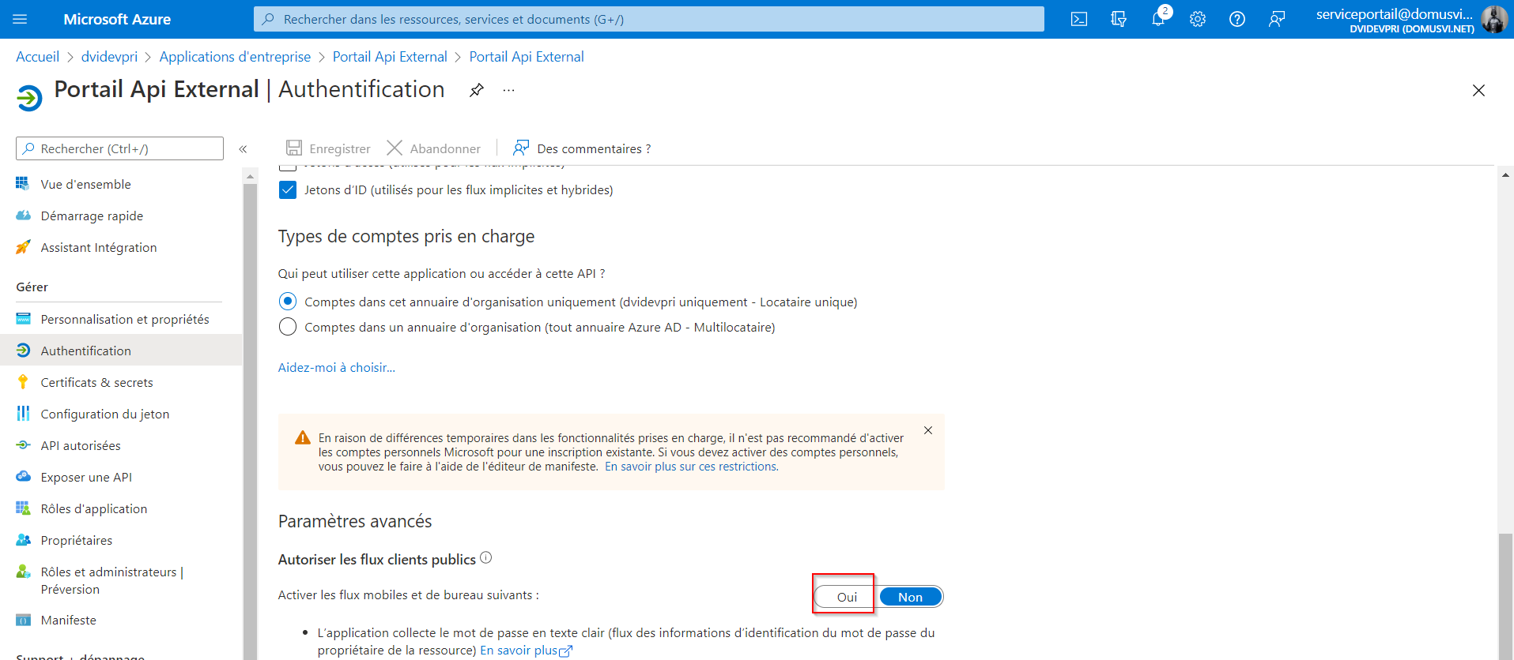

AuthExtSvc.WebApi version MSAL déclenche une exception ci-dessous. Pour la corriger il faut cocher « Oui » client publique pour Portail Api External !!

|  |
| --- |
| A configuration issue is preventing authentication - check the error message from the server for details. You can modify the configuration in the application registration portal. See https://aka.ms/msal-net-invalid-client for details. Original exception: AADSTS7000218: The request body must contain the following parameter: 'client_assertion' or 'client_secret'.  Trace ID: 3308bfe9-588e-4054-ac16-a4c990392d00  Correlation ID: edc09f3b-441c-437e-9134-1c2404784664  Timestamp: 2022-02-11 17:00:47Z  {"error":"invalid_client","error_description":"AADSTS7000218: The request body must contain the following parameter: 'client_assertion' or 'client_secret'.\r\nTrace ID: 3308bfe9-588e-4054-ac16-a4c990392d00\r\nCorrelation ID: edc09f3b-441c-437e-9134-1c2404784664\r\nTimestamp: 2022-02-11 17:00:47Z","error_codes":[7000218],"timestamp":"2022-02-11 17:00:47Z","trace_id":"3308bfe9-588e-4054-ac16-a4c990392d00","correlation_id":"edc09f3b-441c-437e-9134-1c2404784664","error_uri":"https://login.microsoftonline.com/error?code=7000218"} |